DevOps_07_DBB Script

Add groovy files in Build folder.

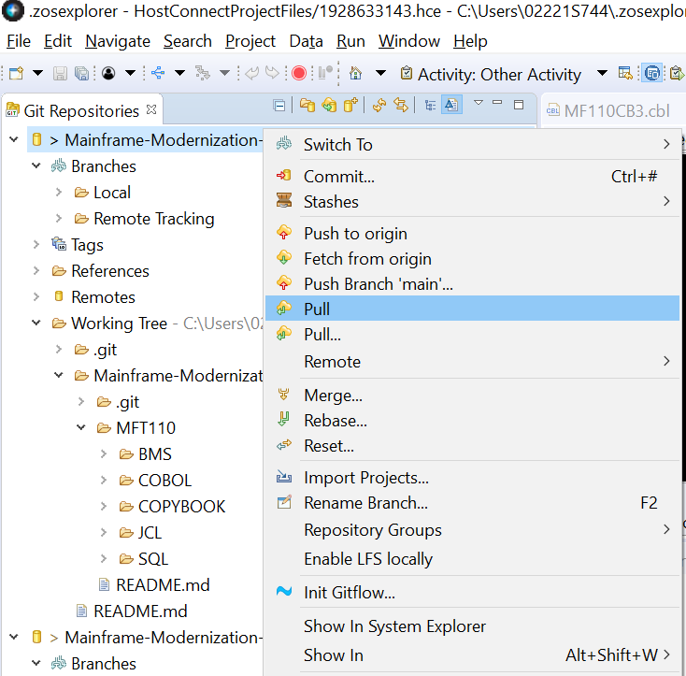

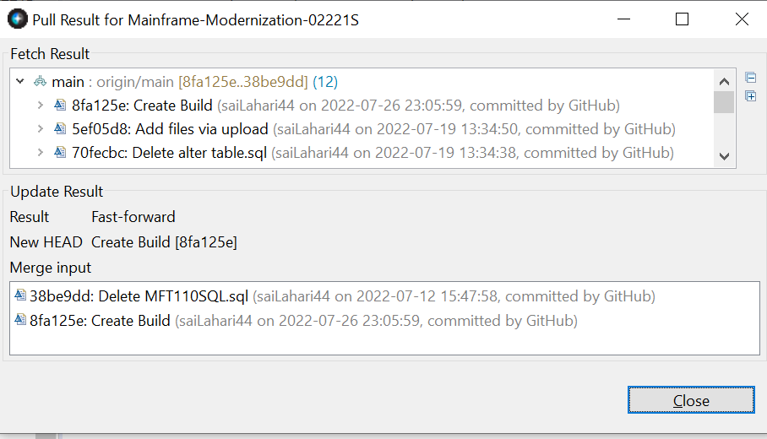

Update the files in Build folder as mentioned below :- Tools.groovy 1. Add vol(VPWRKL) in def create Datasets() {

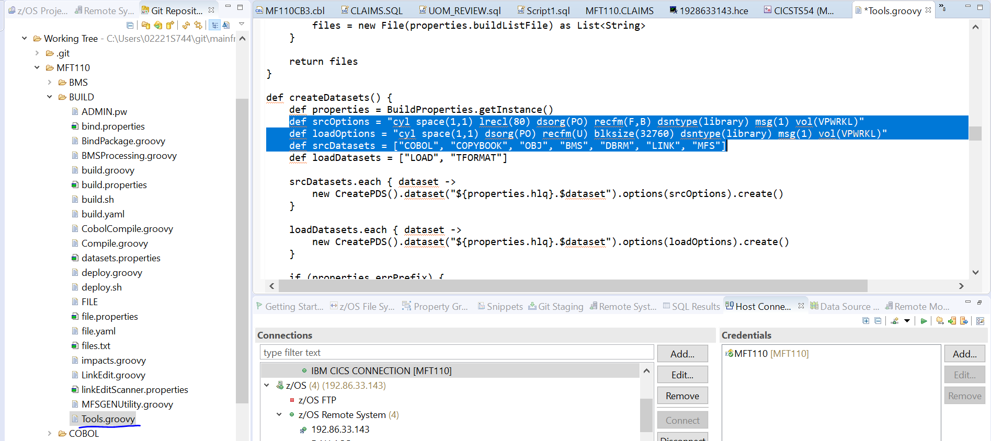

2. Change all “BUILD/MORTGAGE” to “MFT110” Also make sure the folder names are exactly as mentioned in the GITHUB as they are case sensitive.

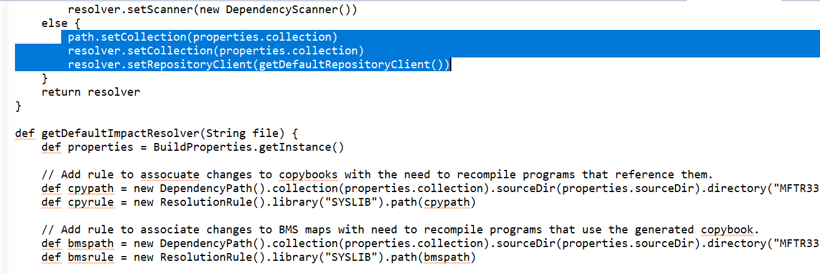

3. Replace files

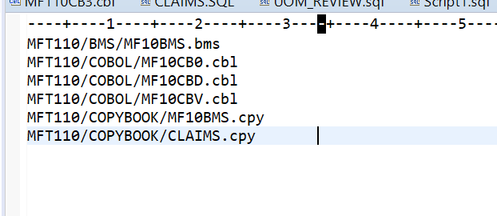

File.yaml :- Change ‘filePatterns’ under Compile and CobolCompile section as below: -“**/*.cbl

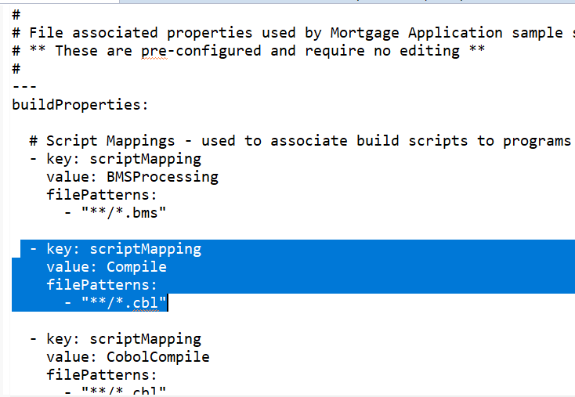

File.properties :- Change Compile and CobolCompile sections as below: scriptMapping = Compile :: **/*.cbl scriptMapping = CobolCompile :: **/*.cb

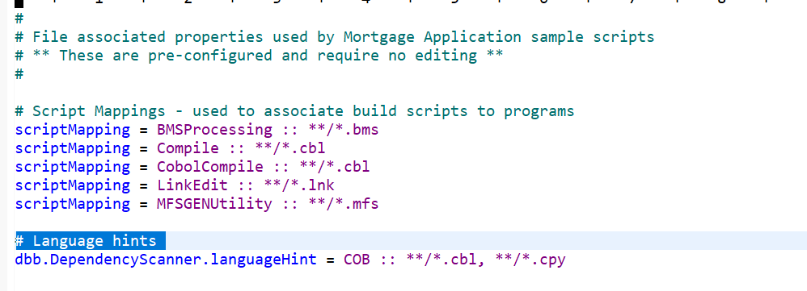

Build.yaml :- Change Mortgage Application on last line to MFTR34

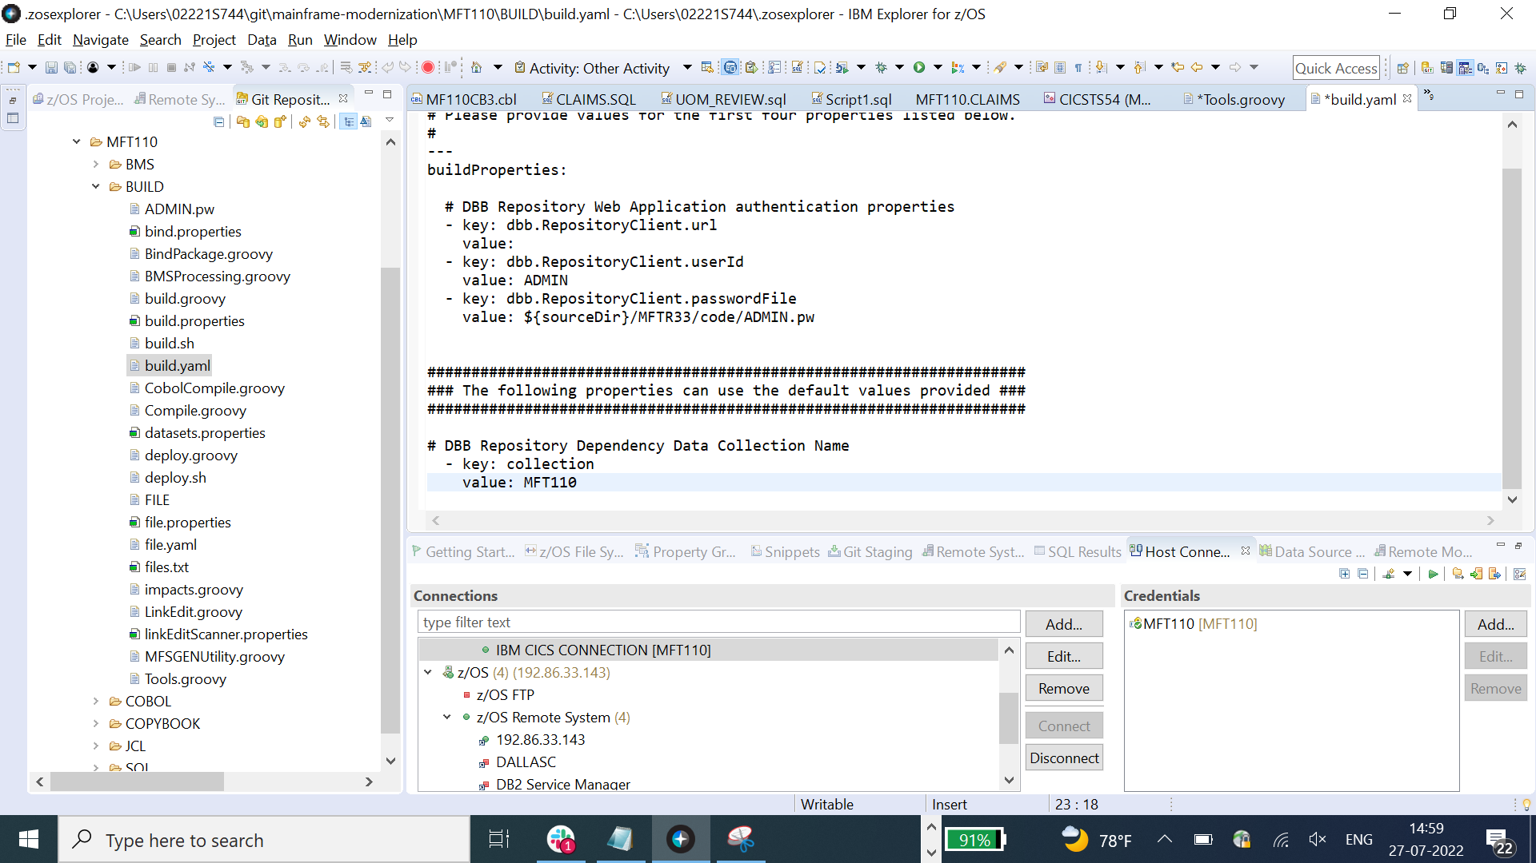

Build.properties :- Change “Build/MortgageApplication” and “MortgageApplication” to “MFT110”

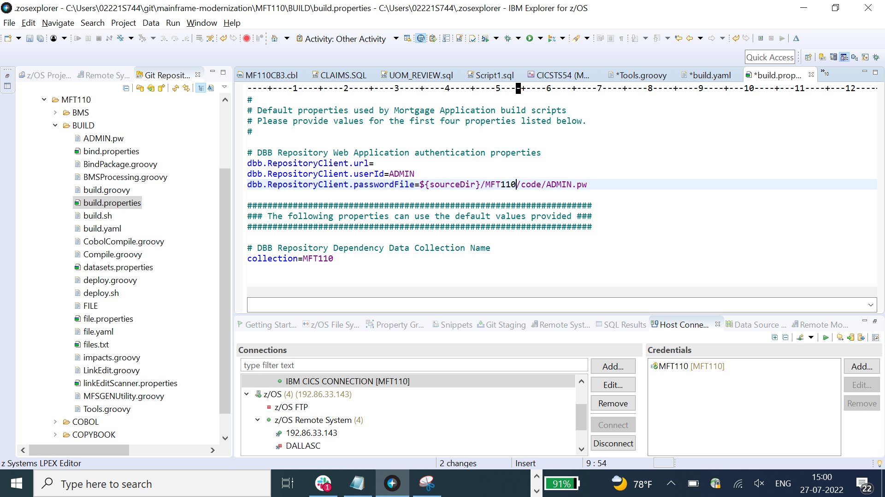

CobolCompile.groovy :- Add below two lines in linkedit section and edit the job.stop() section linkedit.dd(new DDStatement().dsn(“DSNC10.SDSNLOAD”).options(“shr”)) linkedit.dd(new DDStatement().dsn(“MFT110.USER.LOAD”).options(“shr”))

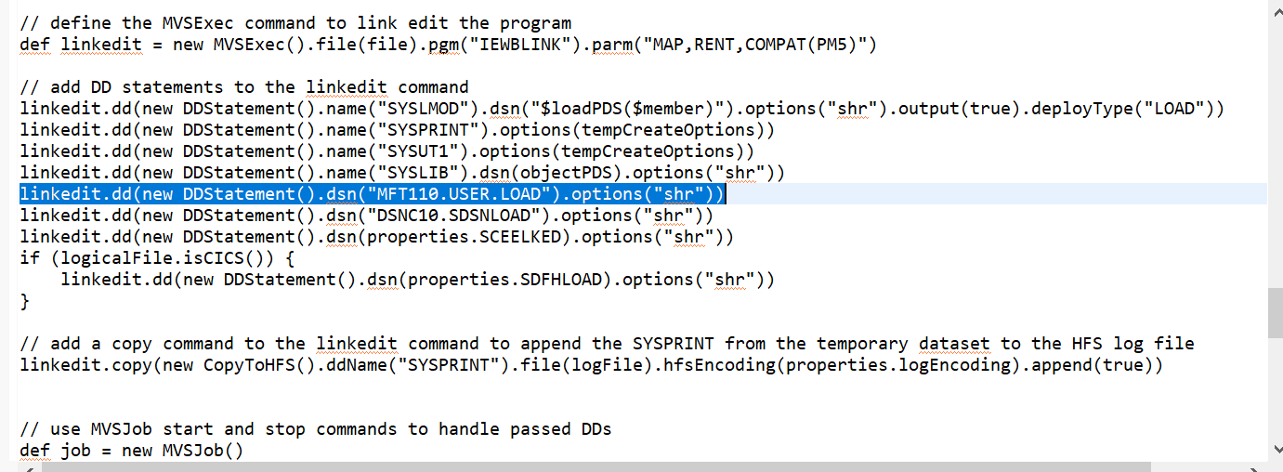

Bind Properties:

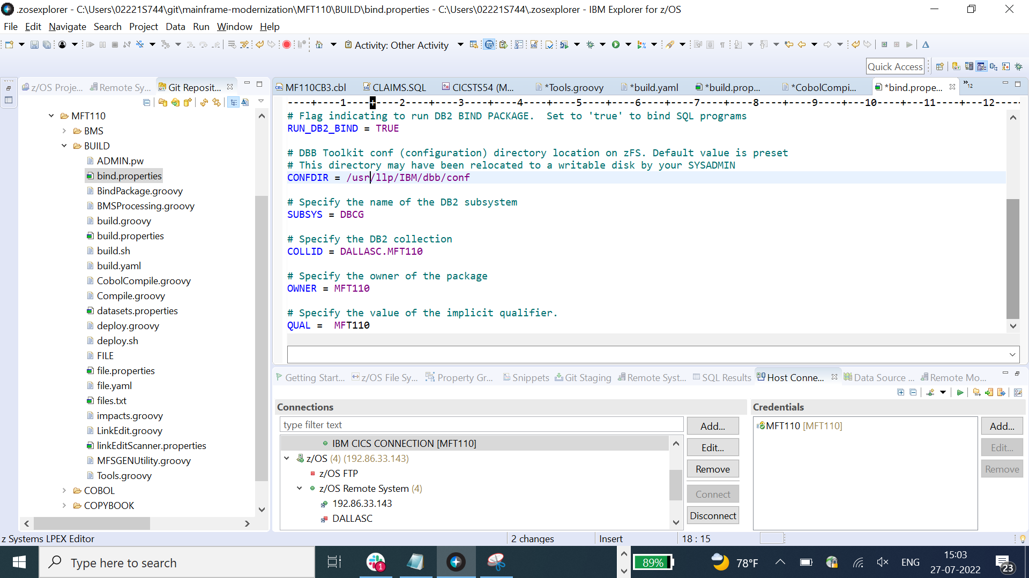

Dataset properties:

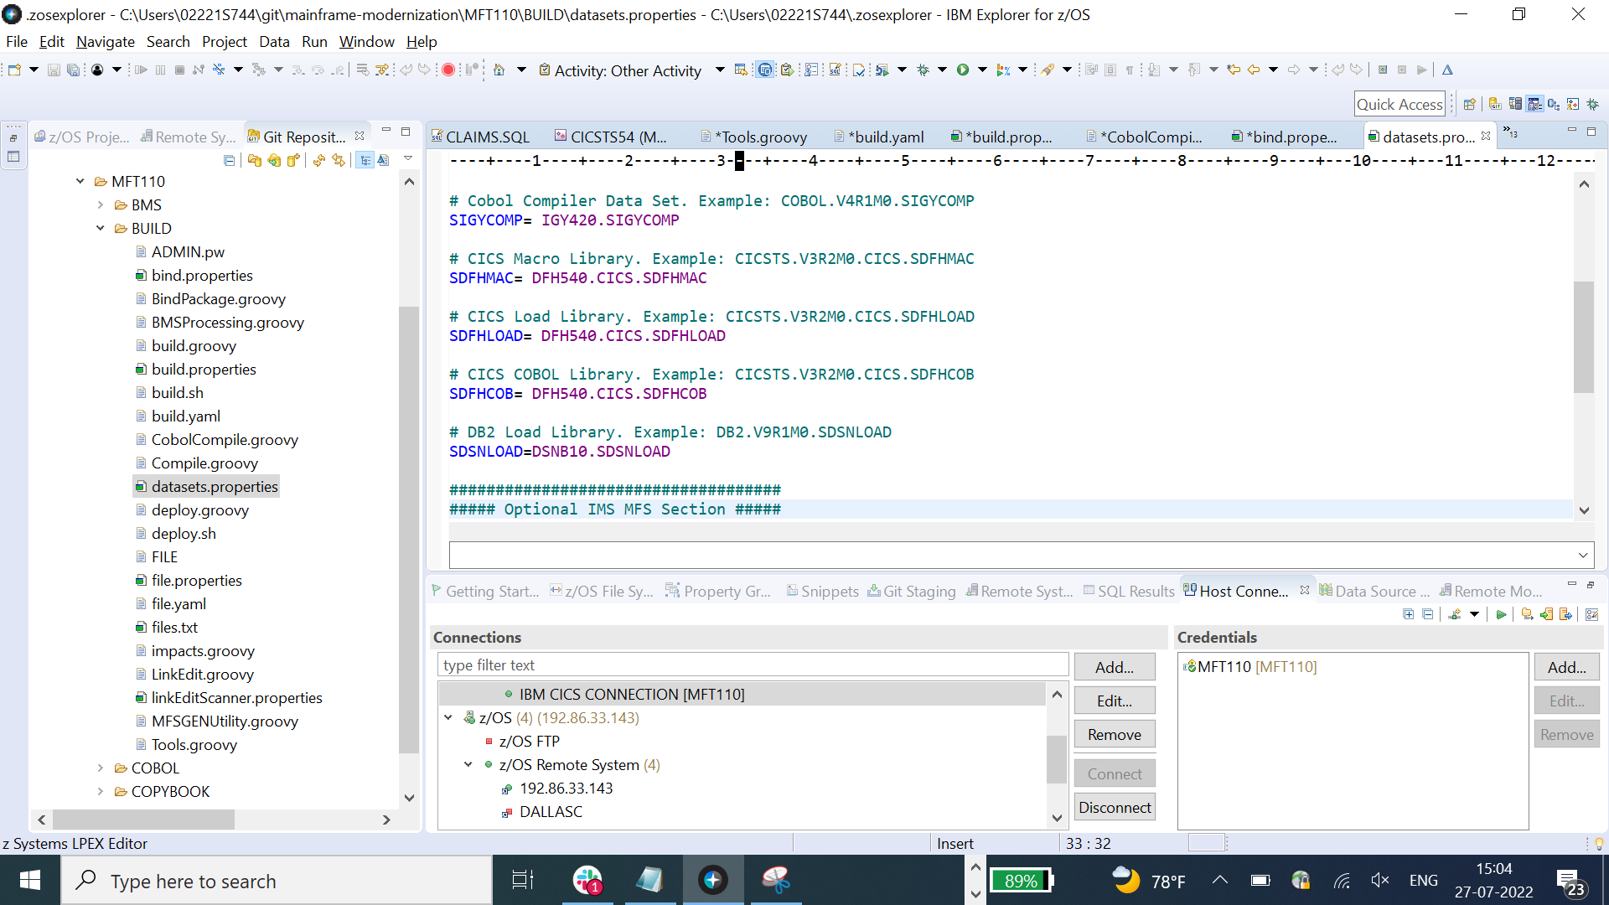

Commit the changes and Push back to the repository

